Extracurricular lesson: “Treasure Island”
Teacher: - Good afternoon, dear guests and children! We are glad to see you! Welcome to our competition! Today we are going to travel to treasure island. We shall sing, we shall dance, We shall speak and read at once! At first, let’s look at the map.
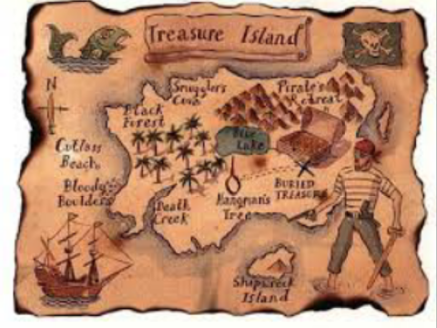
There are 6 stops at the way to treasure island. 1-stop: ABC. 2-stop: Funny numbers. 3-stop: Colours. 4-stop. Name the animals. 5-stop: My body. 6-stop: Our House. Let’s start our travelling!
Our 1-stop is “ABC”. 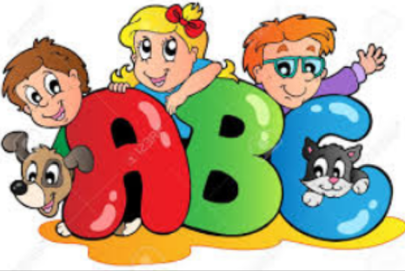
Now you should put the letters in ABC order.
1 | 12 | 16 | 8 | 1 | 2 | 5 | 20
(alphabet)
- Very good!
2-stop is “Funny numbers”. 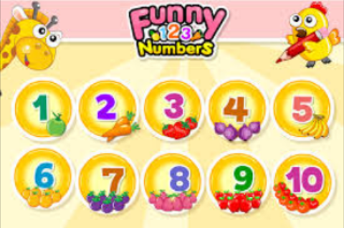
- Children, do you know English numbers? Let’s count from 1 to 10.
- Now I’ll give you papers. There are numerals and their names in English. You must match them on the right way.
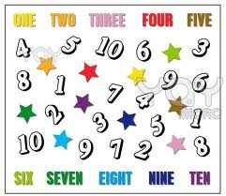
- Well done!
3-stop is “Colours”. 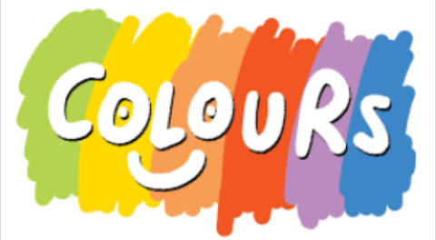
- At this stop we’ll speak about colours. Do you know the names of colours in English? Name them.
- Red, yellow, white, black, blue, green, …
- You are right! Now I’ll give you some pictures and you must colour them in the right way.
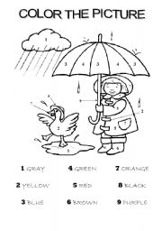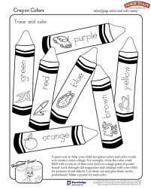
Our 4 – stop is “Name the animals”. 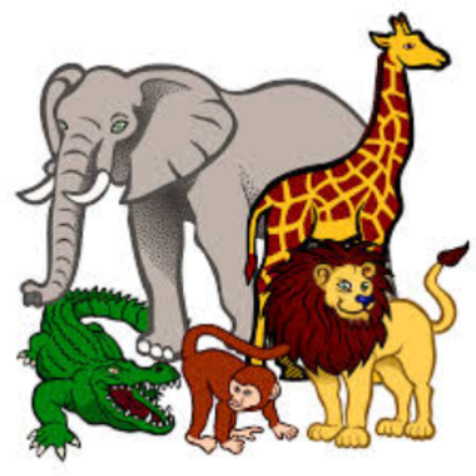
- Children, you know that there are several types of animals. What are they?
- Domestic and wild animals.
- Yes, you are right! Now, try to name them.
- Cat, dog, cow, sheep, horse, …
- Wolf, rabbit, fox, bear, lion, …
- Well done! And now I’ll show you some of them, you must find their names quickly. Let’s go!
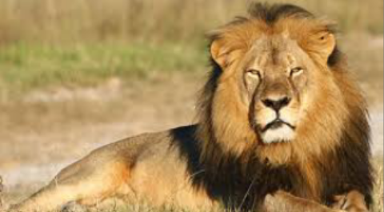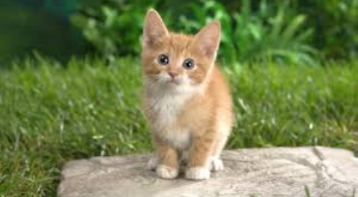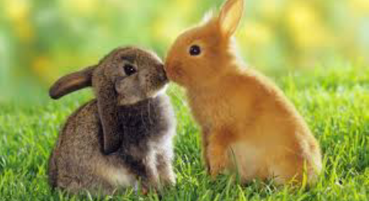

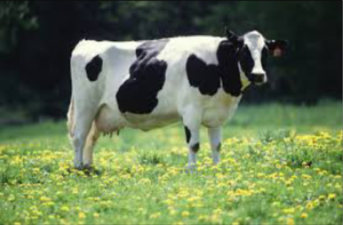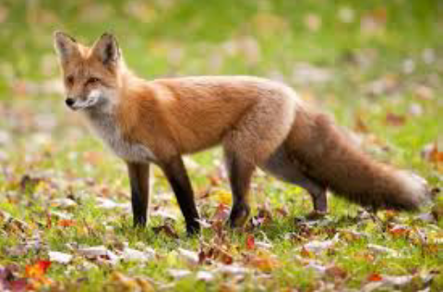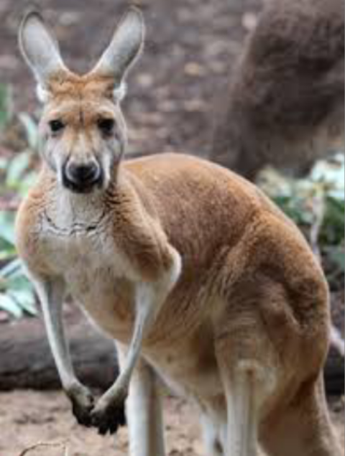

5 – stop is “My body”. 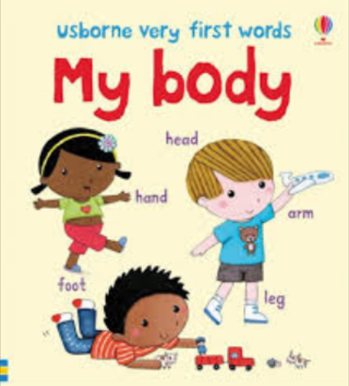
- Our next stop is “My body”. At this stop we’ll speak about our body. You must remember the names of parts of the body. I’ll give you task. There is the picture of boy and the names of parts of body. You’ll match them in the right way.
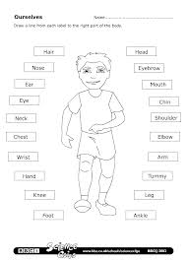
Our last stop is “Our house”.
- At last we’ll speak about our house, rooms and furniture in it. Now you must draw your house and try to describe it in English. Let’s go!
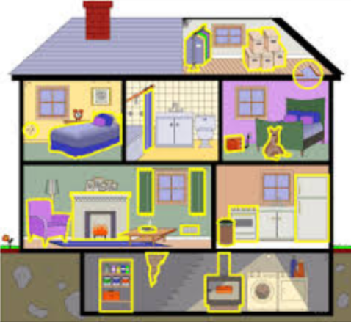

- Well done, dear children! We’ve done all tasks and now we are at treasure island! Let’s try to know what is there.

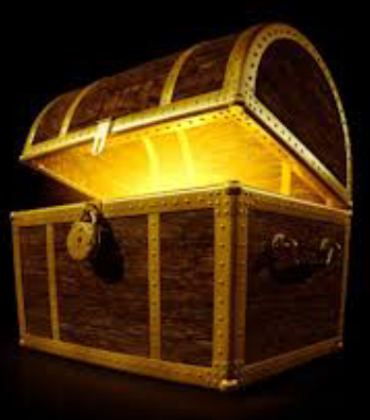

- It’s KNOWLEDGE!!!

